Chemical sensing and imaging with laser-excited THz technology
Toshihiko Kiwa, Masahiro Ogawa, Kousuke Akimune, K. Sakai, and K. Tsukada
¹Graduate school of natural science and technology, Okayama university, Okayama, Japan
Email:kiwa@okayama-u.ac.jp web site: http://www.sense.ec.okayama-u.ac.jp

The attachment should be in the format of either pdf or Microsoft Word. Each abstract should not exceed one page. Please be certain that the presenting author and/or the corresponding author are designated with detailed contact information, including at least their email addresses. [1-4] Fig. 1 shows an example of the figure. The abstract will be printed with black and white ink.

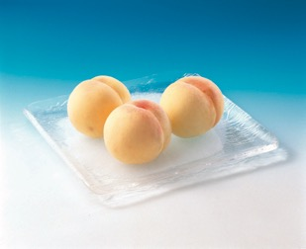
Fig. 1 One of the most ‘expensive’ peaches in Okayama
(Normally, 90 USD)

Reference
- T. Kiwa, J. Kondo, S. Oka, I. Kawayama, H. Yamada, M. Tonouchi, and K. Tsukada, Appl. Opt., 47 [18], 3324 (2008).
- T. Kiwa, T. Hagiwara, M. Shinomiya, K. Sakai, and K. Tsukada, Opt. Express 20, 11637 (2012).
- T. Kiwa, T. Akira, T. Shinji, S. Kenji, and K. Tsukada, Sens. Act. B: Chem., 187, 8 (2013).
- T. Kiwa, K. Sakai, and K. Tsukada, SPIE Newsroom, DOI: 10.1117/2.1201312.005281 (2013).

